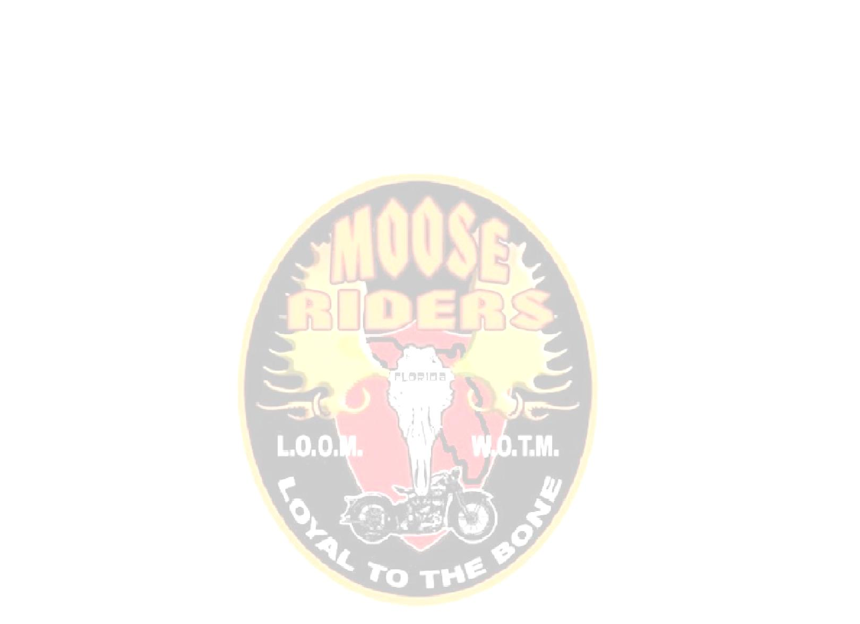
Moose Riders Community Service Report

Lodge Name |  |  | State | Florida |  | District No.

Community Service |  |  |  | Brotherly Love

Mooseheart |  |  | Youth Awareness |  |  |  |  | Youth Sports
Scouting, etc. |  |  | Senior Citizen Programs |  |  |  |  | Other

Chairman: |  |  | Date:

Describe the project:

List all money donations below. Do not include monies raised for moose members in need.

 | To Whom: | Amount
1
2
3
 | Total

Number of Members involved.
Number of Volunteer’s hours.
Personal miles driven for volunteer projects.

List additional information below. Attach newspaper clippings, photographs, letters of appreciation, etc.

